Important Questions with Answers for MID – 1
WDS

- What is the significance of cryptography in view of web security and what are the legal restrictions on cryptography?
- Discuss in detail about privacy-protecting techniques.
- Describe and Differentiate Security vulnerability, threat and Risk?
- Explain different cryptographic protocols.
- Discuss the different types of risks associated with web applications and discuss risk analysis.
- Explain how digital identification enhances trust in web applications.
- What are the different types of backups.
- Discuss the strategies for managing multiple usernames and passwords.
- What points to be considered in choosing an Internet service Provider
- Explain in detail how Kerberos and Diffie-Hellman Alg can be used for authentication?
- Explain the mechanisms used for protecting database server.
- Explain in detail about the different types of Access Control Models for XML.

Answers

- Significance of Cryptography in Web Security & Legal Restrictions
Importance in Web Security
Cryptography is the backbone of secure communication on the internet. It ensures:
- Confidentiality: Data is encrypted so only authorized parties can read it.
- Integrity: Hashing ensures data hasn’t been tampered with.
- Authentication: Digital signatures and certificates verify identities.
- Non-repudiation: Prevents denial of actions (e.g., signed transactions).
Applications:
- HTTPS (SSL/TLS)
- Secure email (PGP, S/MIME)
- VPNs
- Blockchain and digital currencies

Legal Restrictions
Cryptography is regulated to balance privacy and national security:
- Export Controls: Many countries restrict exporting strong encryption (e.g., U.S. EAR regulations).
- Government Access: Some laws mandate backdoors or key escrow (e.g., India’s IT Act).
- Use Restrictions: In some regions, using certain encryption tools without registration is illegal.

- Privacy-Protecting Techniques
Key Techniques
- End-to-End Encryption: Ensures only sender and receiver can read messages (e.g., Signal, WhatsApp).
- Anonymous Browsing: Tools like Tor or VPNs mask IP addresses.
- Secure Search Engines: DuckDuckGo, Startpage avoid tracking.
- Cookie Management: Blocking third-party cookies reduces tracking.
- Browser Extensions: Privacy Badger, Ghostery block trackers.
- Data Minimization: Collect only necessary user data.
- Differential Privacy: Adds noise to datasets to protect individual identities.

- Vulnerability vs Threat vs Risk

Term | Definition | Example
Vulnerability | Weakness in a system that can be exploited | Unpatched software
Threat | Potential cause of harm exploiting a vulnerability | Malware, phishing
Risk | Likelihood and impact of a threat exploiting a vulnerability | Data breach due to weak password

Formula: Risk = Threat × Vulnerability

- Cryptographic Protocols
Common Protocols
- SSL/TLS: Secures web traffic (HTTPS)
- IPSec: Secures IP communications (VPNs)
- SSH: Secure remote login
- PGP: Encrypts emails
- Kerberos: Network authentication using tickets
- Diffie-Hellman: Secure key exchange
- OAuth: Authorization for APIs
- S/MIME: Secure email messaging

- Discuss the different types of risks associated with web applications and discuss risk analysis.
Part 1: Types of risks associated with web applications
Web applications face several security and operational risks. The major types are:
1. Security Risks
These occur due to vulnerabilities in web applications.
- SQL Injection – Attacker inserts malicious SQL queries to access or modify data.
- Cross-Site Scripting (XSS) – Malicious scripts are injected into web pages.
- Cross-Site Request Forgery (CSRF) – Unauthorized commands executed using a user’s session.
- Broken Authentication – Weak login mechanisms allow unauthorized access.
- Session Hijacking – Stealing user session IDs to impersonate users.

2. Data Risks
Risks related to loss or misuse of data.
- Data Breach – Sensitive user data is exposed.
- Data Loss – Data may be deleted or corrupted.
- Improper Data Storage – Storing data without encryption.

3. Availability Risks
These affect the accessibility of web applications.
- Denial of Service (DoS / DDoS) Attacks – Overloading servers to make services unavailable.
- Server Failures – Hardware or software crashes.
- Network Issues – Connectivity problems.

4. Privacy Risks
Threats to user privacy.
- Unauthorized Data Collection
- Tracking Without Consent
- Violation of Privacy Policies

5. Compliance and Legal Risks
Failure to follow laws and standards.
- Non-compliance with regulations (GDPR, IT Act, etc.)
- Improper handling of personal data
- Legal penalties and fines

6. Operational Risks
Risks arising from poor management or processes.
- Configuration Errors
- Outdated Software
- Poor Backup and Recovery Plans

Part 2: Risk Analysis in Web Applications
Definition:
Risk analysis is the process of identifying, assessing, and managing risks to reduce their impact on a web application.

Steps in Risk Analysis
1. Risk Identification
- Identify potential threats and vulnerabilities.
- Example: SQL injection, weak passwords.

2. Risk Assessment
- Evaluate likelihood and impact of each risk.
- Classify risks as High, Medium, or Low.

3. Risk Evaluation
- Decide which risks need immediate attention.
- Prioritize based on severity.

4. Risk Mitigation
- Apply controls to reduce risks.
- Examples:
  - Input validation
  - Encryption
  - Firewalls
  - Regular updates

5. Risk Monitoring and Review
- Continuously monitor risks.
- Update security measures as new threats emerge.

- Explain how digital identification enhances trust in web applications.
Digital identification is the process of verifying the identity of users, devices, or organizations in an online environment. It plays a crucial role in building trust in web applications by ensuring secure and reliable interactions.

1. User Authentication:
Digital IDs verify that users are who they claim to be.
Uses mechanisms like usernames/passwords, biometrics, OTPs, and digital certificates.
Prevents unauthorized access and impersonation.

2. Data Security and Confidentiality:
Digital identification enables secure login sessions.
Ensures that sensitive information is accessed only by authorized users.
Builds confidence that personal and financial data is protected.

3. Integrity of Transactions:
Digital signatures ensure that data is not altered during transmission.
Helps detect tampering in online transactions.
Enhances trust in e-commerce and online banking applications.

4. Non-Repudiation:
Digital identification ensures that users cannot deny their actions.
Digital signatures provide proof of origin and action.
Important for legal and financial transactions.

5. Secure Communication:
Digital certificates (SSL/TLS) authenticate websites.
Users can verify that they are interacting with a legitimate website.
Prevents phishing and man-in-the-middle attacks.

6. Access Control:
Digital IDs help assign roles and permissions.
Users access only what they are authorized to use.
Improves system reliability and accountability.

7. Compliance and Legal Trust:
Supports compliance with legal and regulatory requirements.
Digital IDs are legally recognized in many countries.

- Types of Backups
Type | Description
Full Backup | Entire data copied
Incremental Backup | Only changes since last backup
Differential Backup | Changes since last full backup
Mirror Backup | Exact replica; deletes files if removed from source
Local Backup | Stored on physical devices (e.g., HDD, NAS)
Offsite Backup | Stored in remote locations or cloud
Cloud Backup | Online backup services (e.g., Google Drive, AWS)

- Managing Multiple Usernames and Passwords
Strategies
- Password Managers: Tools like Bitwarden, LastPass store and generate strong passwords.
- Multi-Factor Authentication (MFA): Adds extra layer (OTP, biometrics).
- Single Sign-On (SSO): One login for multiple services.
- Unique Passwords: Avoid reuse across platforms.
- Regular Updates: Change passwords periodically.
- Avoid Browser Storage: Use encrypted vaults instead.

- Choosing an Internet Service Provider (ISP)
Key Considerations
- Availability: Coverage in your area
- Speed: Download/upload rates
- Reliability: Uptime and performance
- Cost: Monthly fees, installation charges
- Contract Terms: Lock-in periods, cancellation fees
- Customer Support: Responsiveness and service quality
- Security: Protection against malware, firewalls
- Bundled Services: TV, phone, cloud storage
Elaborated Answer:
While selecting an Internet Service Provider (ISP), the following points should be considered:
- Internet Speed
The ISP should offer adequate download and upload speeds based on user requirements.
- Reliability and Uptime
The service should be stable with minimal downtime.
- Cost and Tariff Plans
Compare pricing, installation charges, and monthly plans.
- Data Limits
Check for unlimited data or fair usage policy (FUP).
- Coverage Area
The ISP should provide good connectivity in the user’s location.
- Type of Connection
Fiber, broadband, cable, DSL, or wireless connection options.
- Customer Support
Availability of quick and effective technical support.
- Security Features
Firewalls, antivirus protection, and secure connections.
- Reputation of ISP
Reviews and feedback from existing users.
- Additional Services
Email accounts, static IP, cloud storage, or bundled services.

- Kerberos & Diffie-Hellman for Authentication
Kerberos
- Uses a Key Distribution Center (KDC) with:
  - Authentication Server (AS)
  - Ticket Granting Server (TGS)
- Process:
  - User logs in → gets Ticket Granting Ticket (TGT)
  - TGT used to request service ticket
  - Service ticket used to access resources
Diffie-Hellman
- Enables secure key exchange over insecure channels.
- Each party generates a private and public key.
- Shared secret is computed using: $$ \text{Shared Key} = g^{ab} \mod p $$
- Used in VPNs, TLS, and secure messaging.

- Protecting Database Servers
Mechanisms
- Authentication & Authorization: Role-based access
- Encryption: At rest and in transit
- Firewalls: Restrict unauthorized access
- Regular Updates: Patch vulnerabilities
- Database Activity Monitoring (DAM): Logs and alerts
- Backup & Recovery: Regular backups
- Segmentation: Separate production and test environments
- Least Privilege Principle: Minimal access rights

- Access Control Models

Model | Description
DAC | Owner decides access (flexible but less secure)
MAC | Central authority assigns access based on classification
RBAC | Access based on user roles (e.g., admin, HR)
ABAC | Access based on attributes (e.g., time, location, device)
RuBAC | Access based on rules (e.g., time-based restrictions)
OrBAC | Organization-level policies independent of implementation
IBAC | Identity-based access (individual user control)

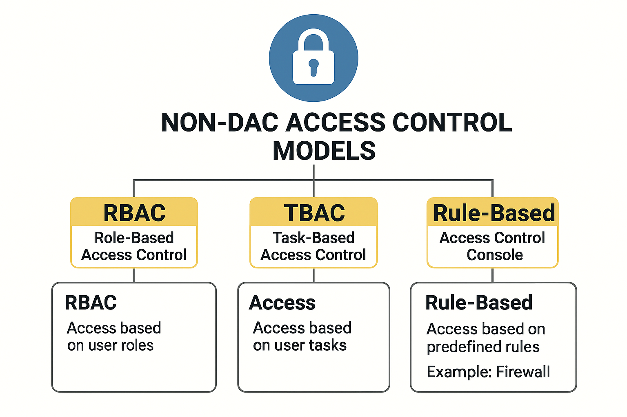
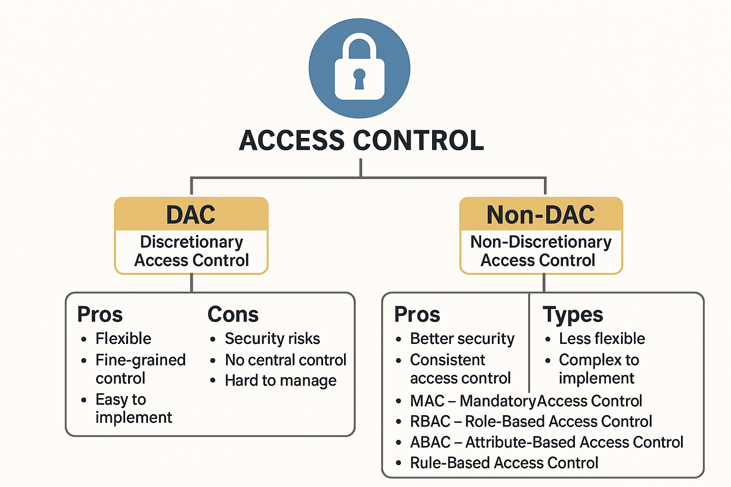

********************* Wish you all the best ******************

